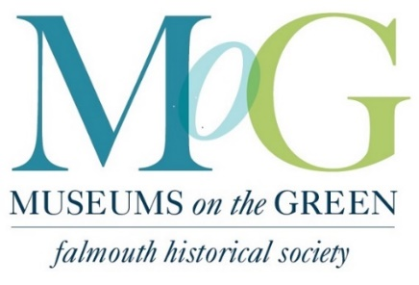
55 & 65 Palmer Avenue │ 508-548-4857 http://museumsonthegreen.org

VOLUNTEER APPLICATION
Date: ________________

Name: ______________________________________________________________________

Address: ____________________________________________________________________

Phone: ___________________ Email: ____________________________________________

Emergency contact: Name:______________________Phone: ________________________

Museums on the Green season is July 1st-October 9th

Wednesday
Wick’s House Docent __10:00-12:30 __12:30-3:00
Hallett Center Greeter __10:00-12:30 __12:30-3:00

Thursday
Wick’s House Docent __10:00-12:30 __12:30-3:00
Hallett Center Greeter __10:00-12:30 __12:30-3:00

Friday
Wick’s House Docent __10:00-12:30 __12:30-3:00
Hallett Center Greeter __10:00-12:30 __12:30-3:00

Saturday
Wick’s House Docent __10:00-1:00
Hallett Center Greater __10:00-1:00

Special Events __Lecture Greeter __Antique Sale __Community Events
Handy Help __Yard Work __Painting __Carpentry __Heating/Plumbing

